Quiz Sec B

Structures

Q1: Write a program to sum two complex numbers. your program should take two complex numbers as structures and add them with the use of functions.

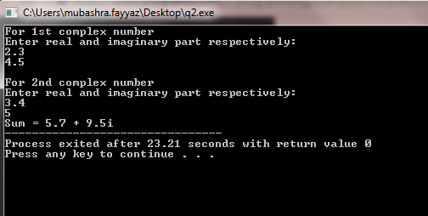

Q2: Ali is confused with time periods he wants you to write a program that calculates the difference between two time periods using user defined - "differenceBetweenTimePeriod" function.

